Masks, false safety and real dangers, Part 1:
Friable mask particulate and lung vulnerability

Boris Borovoy, Colleen Huber, Q Makeeta

Abstract

There is no biological history of mass masking until the current era. It is important to consider possible outcomes of this society-wide experiment. The consequences to the health of individuals is as yet unknown.

Masked individuals have measurably higher inspiratory flow than non-masked individuals. This study is of new masks removed from manufacturer packaging, as well as a laundered cloth mask, examined microscopically. Loose particulate was seen on each type of mask. Also, tight and loose fibers were seen on each type of mask. If every foreign particle and every fiber in every facemask is always secure and not detachable by airflow, then there should be no risk of inhalation of such particles and fibers. However, if even a small portion of mask fibers is detachable by inspiratory airflow, or if there is debris in mask manufacture or packaging or handling, then there is the possibility of not only entry of foreign material to the airways, but also entry to deep lung tissue, and potential pathological consequences of foreign bodies in the lungs.

Introduction

The nose and mouth are the gateways to the lungs for land vertebrates. There is no known history of a species that has begun to voluntarily or involuntarily obstruct, partially obstruct or filter the orifices to their airways and lungs. We have no biological history of such a species or how they would have adapted to or possibly survived such a novel practice.

However, recently, in mid-2020, throughout the world, in some countries far more than others, human self-masking has become commonplace, whether due to insistence by governments, requirement of employers, educational institutions and business-owners, or social pressures in one’s immediate social circles. The proximal reason behind these reasons is abundant fear and desire for protection from COVID-19 throughout the world in 2020. People have been either coerced or otherwise pressured to wear “face coverings,” allegedly for the purpose of “slowing the spread of COVID-19.” The general public’s response is to use disposable surgical masks, and a wide variety of cloth masks and other cloth face coverings. In the western hemisphere at least these facemasks had not been worn outside of certain hospital facilities, not outside of surgical settings and intensive care units of hospitals.

Prior research has overwhelmingly shown that there is no significant evidence of benefits of masks, particularly regarding transmission of viral infections, and that there are well-established risks. Evidence from peer-reviewed clinical studies and meta-analyses on problems concerning the effectiveness and safety of masks are summarized in this article.

Optimal oxygen intake in humans has been calculated in the absence of any obstruction to the airways. The US Occupational Safety and Health Administration (OSHA) has determined that the optimal range of oxygen in the air for humans is between 19.5 and 23.5%. In previous times, before the COVID-19 era, OSHA required that any human-occupied airspace where oxygen measured less than 19.5% to be labelled as “not safe for workers.” The percentage of oxygen inside a masked airspace generally measures 17.4% within several seconds of wearing. It has been observed that maximal voluntary ventilation and maximal inspiratory pressure increase during lower availability of oxygen at ascent in altitude, as well as for those who live at high altitude. Because oxygen is so essential to life, and in adequate amounts, humans and animals have developed the ability to sense changes in oxygen concentration, and to adapt to such challenges quickly. The medulla oblongata and carotid bodies are sensitive to such changes. Both lower ambient oxygen and increased ambient carbon dioxide stimulates ventilation, as the body quickly and steadfastly attempts to acquire more oxygen. As a compensatory mechanism, inspiratory flow is measurably higher in mask-wearers than in controls.

The question then arises: If inspiratory flow is increased over normal while wearing a mask, is every fiber attached to one’s facemask secure enough not to be inhaled into the lungs of the mask-wearer? Is it good enough for a majority of these fibers to be secure? Or must every part of every mask fiber of every mask be secure at all times?

Materials Used in Masks

Inhaled cotton fibers have been shown to cause subpleural ground glass opacities at the surface of the visceral pleura, as well as centrilobular and peribronchovascular interstitial thickening, as well as fibrous thickening of peribronchiolar interstitium. It was found by spectral analysis by infrared spectrophotometry that the foreign bodies in the lungs had an identical pattern to that of cellulose, which must have come from the inhaled cotton fibers. Cotton and even silk may contribute to COPD in textile workers. Byssinosis is a pulmonary syndrome related to textile work. When textile workers were exposed to organic dusts from textiles in the workplace, both reversible and irreversible pulmonary conditions, such as asthma and COPD developed. It should be remembered that unmasked textile workers would not have such high inspiratory flow as masked individuals.

Therefore, there is even more need that the fibers, debris and other particulate attached to cloth masks would stay entirely intact; every fiber, and every part of every fiber, and throughout every breath, at all times, even down to the size of nanometers.

Disposable surgical face masks are made of synthetic fibers, including polymers such as polypropylene, polyurethane, polyacrylonitrile, polystyrene, polycarbonate, polyethylene or polyester. There is an inner layer of soft fibers and a middle layer, which is a melt-blown filter, as well as a water-resistant outer layer of nonwoven fibers. This study shows FT-IR spectra of the degrading fibers of disposable masks. It found that disposable face masks “could be emerging as a new source of microplastic fibers, as they can degrade/fragment or break down into smaller size/pieces . . . .

Research on synthetic fibers has shown a correlation between the inhalation of synthetic fibers and various bronchopulmonary diseases, such as asthma, alveolitis, chronic bronchitis, bronchiectasis, fibrosis, spontaneous pneumothorax and chronic pneumonia. Cellular proliferation made up of histiocytes and fibroblasts were found in the lungs of those exposed to synthetic fibers in ambient air. Focal lesions in the lungs showed granulomas and collagen fibers containing both fine dust and long fibers. Some of the lung illnesses from this exposure could be reversed, while others had already proceeded to pulmonary fibrosis.
Bioburden of masks has also been established. This study found bioburden on each type of mask studied, even after first use in a surgical environment. Speaking while wearing masks resulted in a significantly higher bioburden cultured from the face side of a mask.

Possible Risk of Pulmonary Fibrosis

Pulmonary fibrosis is among the worst diseases that can be suffered or witnessed. It kills exceedingly slowly, by ever-thickening matrix formation, a kind of scar tissue, obstructing the alveoli and reducing their air exchange. The illness worsens slowly over time, and suffocates the victim very gradually. Nothing is available to the sufferer from conventional medicine. Neither medication nor radiation can undo the damage of the fibrous matrix laid down in the lungs’ tissue. Similarly, surgery is not available to eliminate the insidious, suffocating mesh that painstakingly takes the life of the unfortunate patient. Neither is any known cure available in the realm of natural or alternative medicine. Neither nutrient, herb, nor any other known treatment can even reduce the fibrogenesis, let alone eliminate it. The 5-year survival rate is only 20%. The only remedy against this scourge is diligent prevention of small and microscopic inhaled foreign bodies.

Inhaled particles, particularly nanoparticles, can begin the process of pulmonary fibrosis by forming free radicals such as superoxide anions. The resulting oxidative stress promotes inflammatory responses and surface reactivity. The pathogenesis of idiopathic pulmonary fibrosis begins when Type 2 alveoli are injured and epithelia is not fully healed. Interstitial fibroblasts differentiate into myofibroblasts, which gather in fibrotic foci and form fibers with contractile properties. This is followed by synthesis and deposit of extracellular matrix, which seems to be key in suffocating the air exchange of alveoli.

Particles of nanometer to micrometer size have been implicated as causative agents in pulmonary fibrosis. Airborne inhaled nano-size particles are especially dangerous for the lungs, but are small enough to undergo transcytosis across epithelial and endothelial cells to enter blood and lymph, reaching the cardiovascular system, spleen, bone marrow, and have been observed to travel along axons and dendrites of the central nervous system and ganglia, a phenomenon that has been known for decades.

Inhaled particles of 20 nm have deposited, more than other sizes of nano-particles, in the alveolar region, during nose-breathing of a person at rest.

Methods

We examined microscopically the concave face side of a variety of new masks, taken directly out of their packaging from the manufacturer, not yet worn. However, the cloth mask below was worn for one day, and then laundered, and never worn again.

The following are the types of masks and the macroscopic view of the face side of each:

Cup mask | 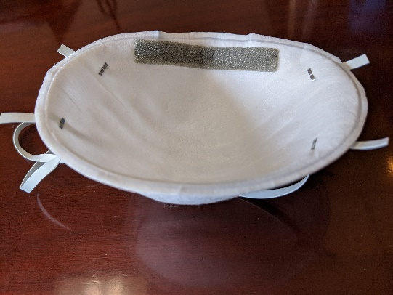 | Cloth mask, worn one day, then laundered, and not used again | 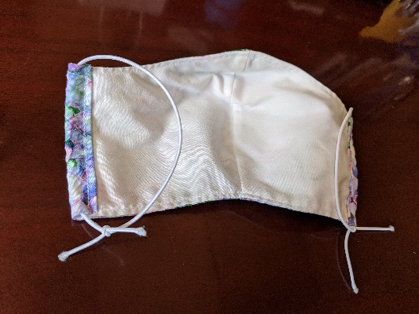
N-95 mask #1 | 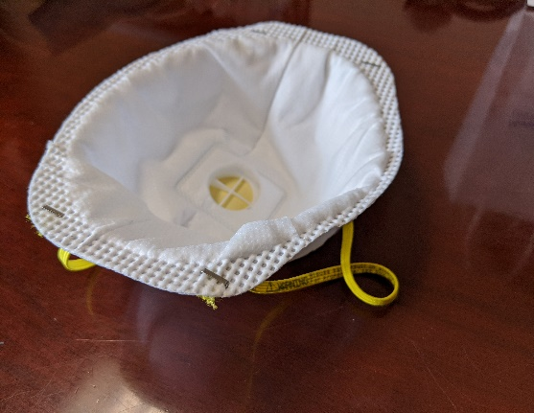 | N-95  mask #2 | 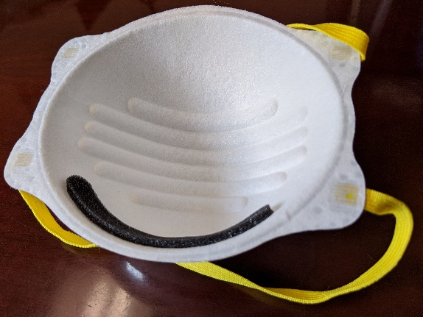
Surgical mask | 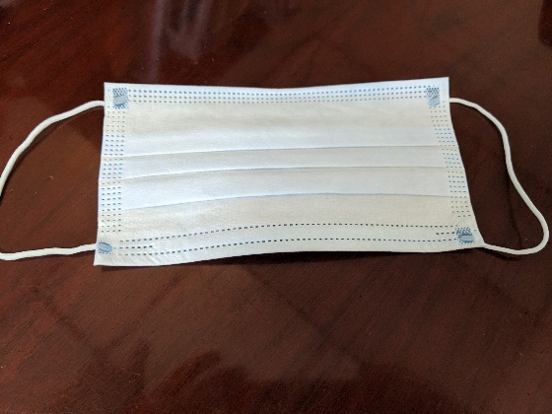

The following photos were taken of the same masks at 40x to 100 x magnification.
Higher resolution photos from other sources are in Appendix A.

Cup mask particulate and soiled appearing fibers

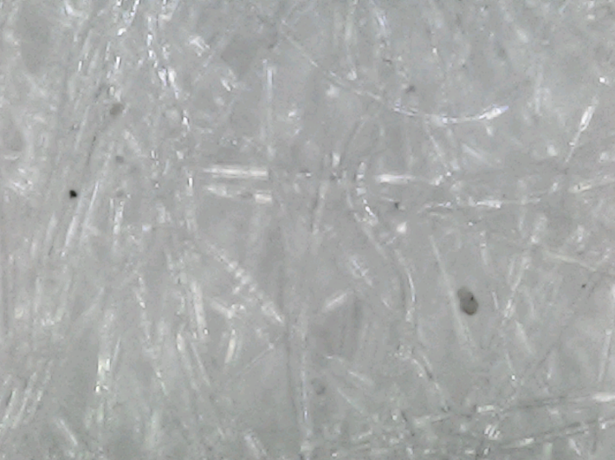 | 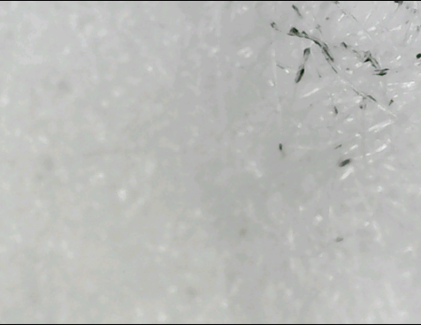
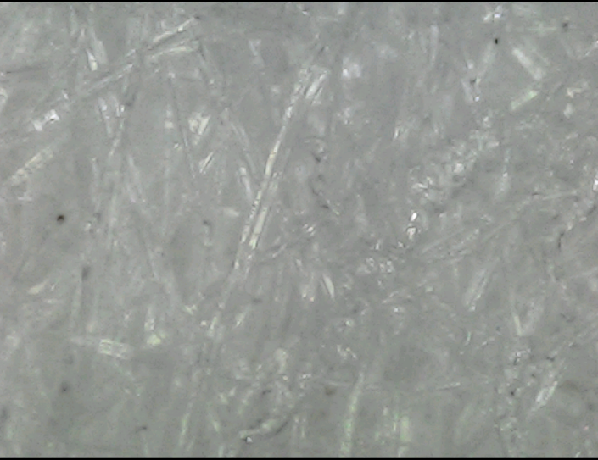 | 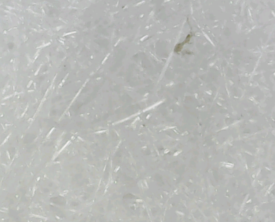

Cloth mask particulate and loosened fibers after one day use and laundering once

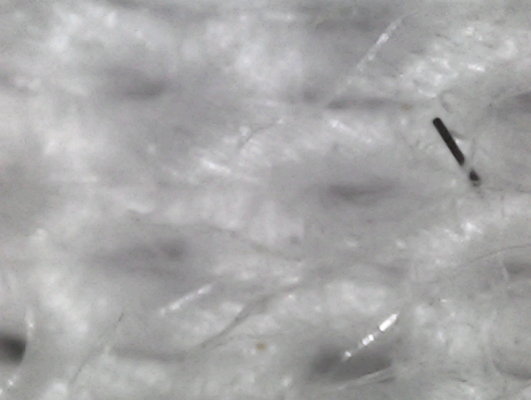 | 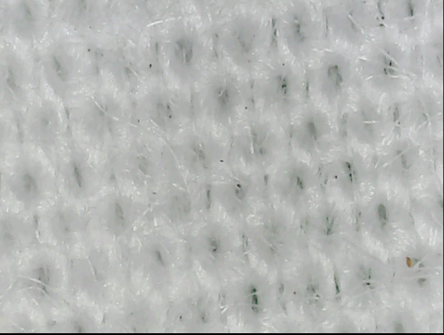
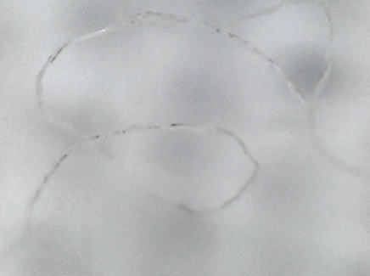 | 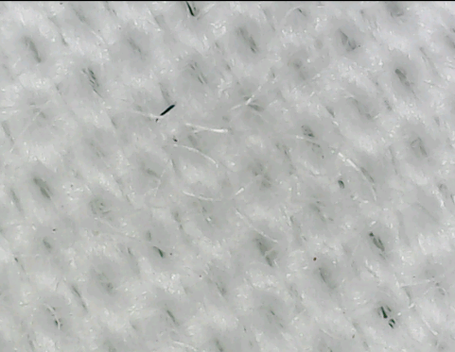

Surgical mask soiled appearance and particulate

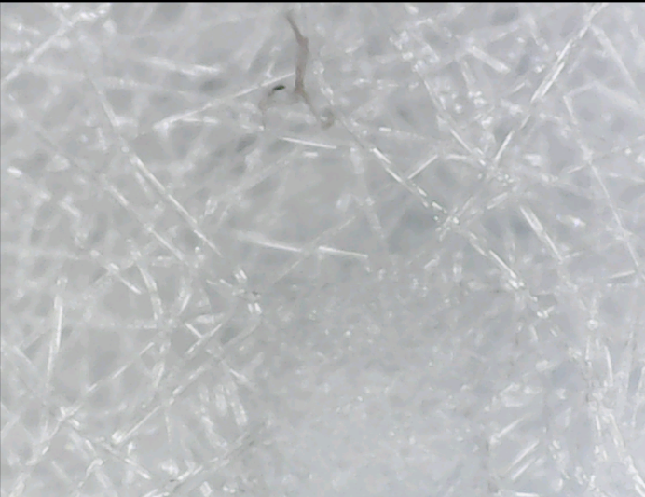 | 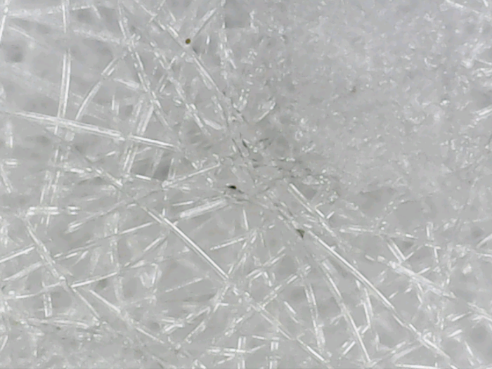
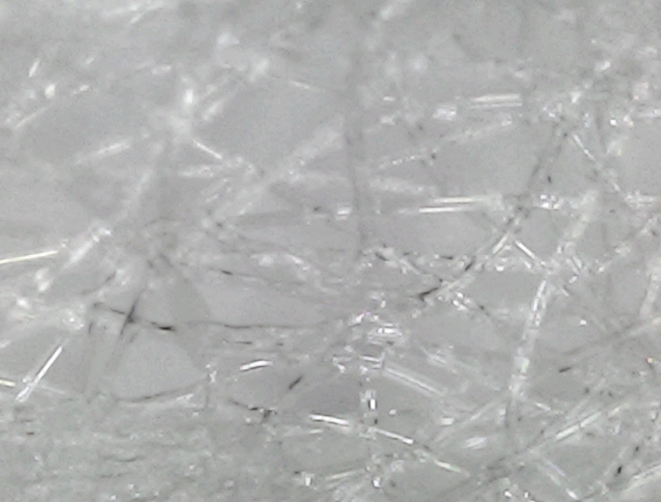 | 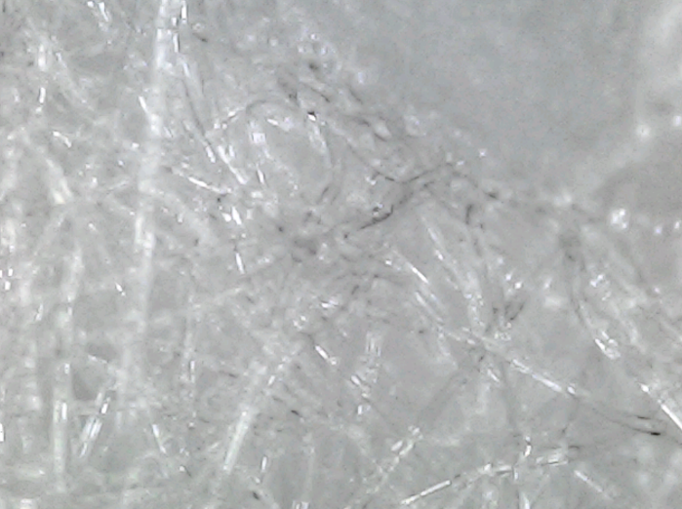

N-95 #1 particulate and soiled appearing fibers

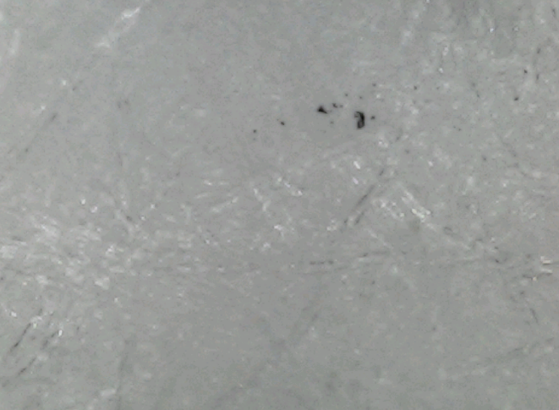 | 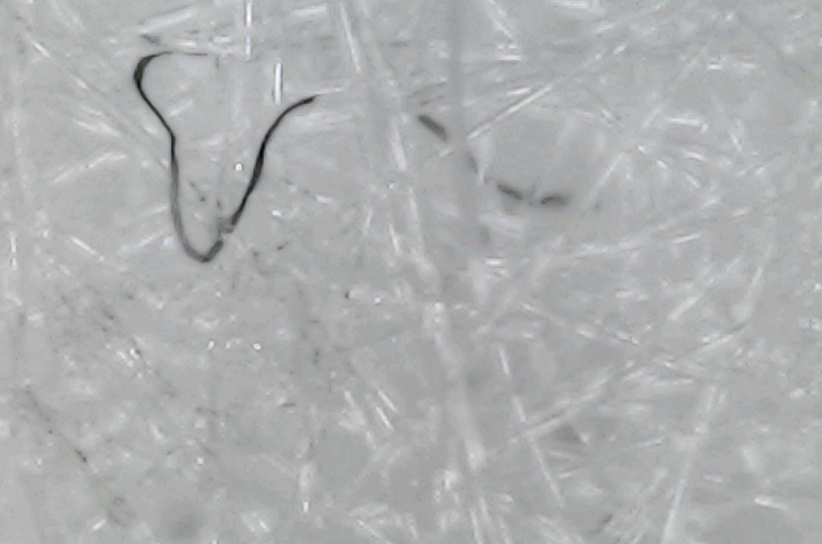
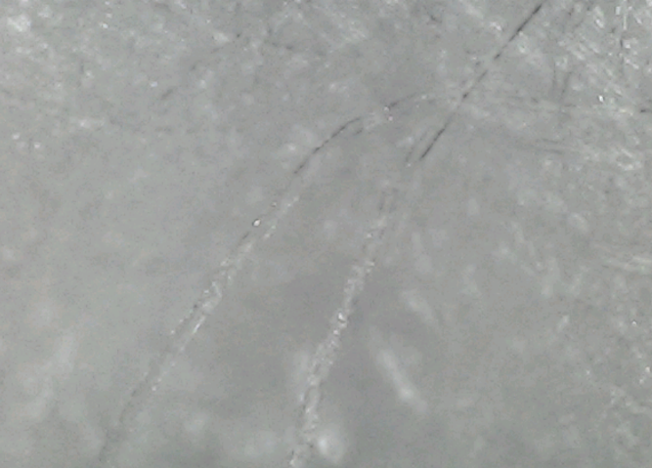 | 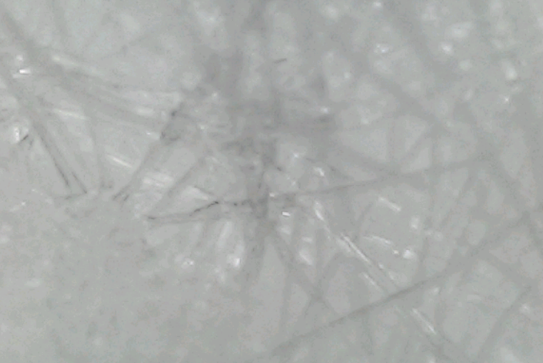

N-95 #2 particulate

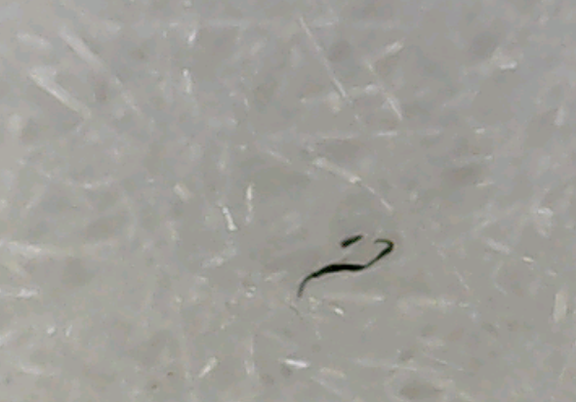 | 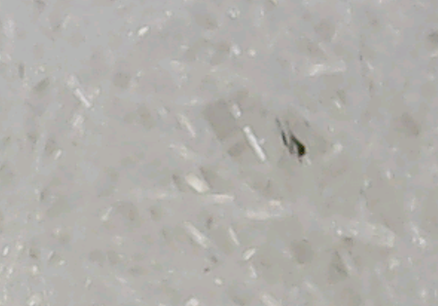
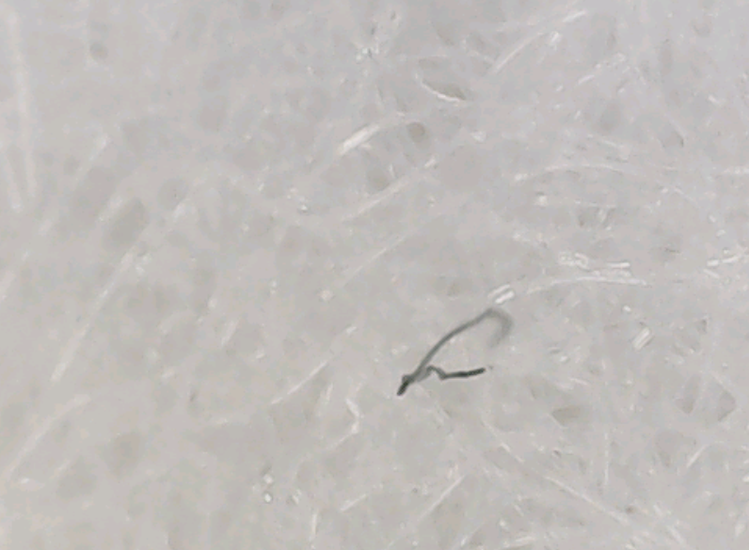 | 

On the other hand, when masks are used, particulate and fibers may become further loosened. The following photo shows a lightly used hospital face mask illuminated by a consumer LED flashlight.

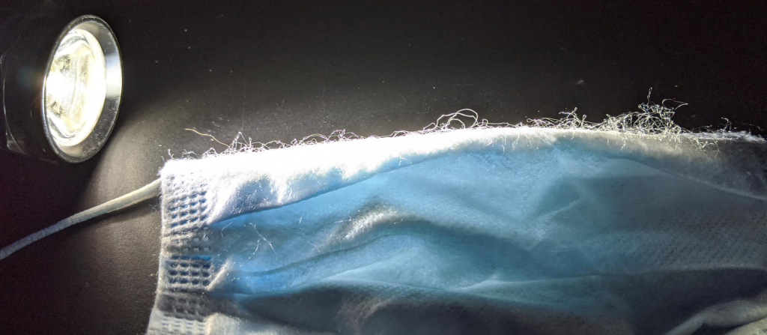

Results

A variety of face masks were examined macroscopically and microscopically. Each type of new, just unpackaged mask showed particulate matter and/or unidentified fibers. The first N-95 showed the fewest loose particles. All of the masks showed partially loose fibers in nearly every visual field. The cloth mask had been used previously but was laundered and then not used again. This also showed loose fibers dangling from the woven fabric of the mask, as well as particulate debris. The cloth mask had more loose fibers than the others, typically 4 or 5 partially loose or dangling fibers that were compressible toward the weave in each visual field.

The unclean appearance surrounding the oval shapes of the surgical mask may be due to an artifact of the thermal processing of mask textile. This may be some drops of melted polyethylene or other polymer plastic.

Conclusion

Surgical personnel are trained to never touch any part of a mask, except the loops and the nose bridge. Otherwise, the mask is considered useless and is to be replaced. Surgical personnel are strictly trained not to touch their masks otherwise. However, the general public may be seen touching various parts of their masks. Even the masks just removed from manufacturer packaging have been shown in the above photos to contain particulate and fiber that would not be optimal to inhale.

Both cotton and polymer clothing have been well-tolerated without pathology when covering any other part of the body, except over the only entry points/gateway to the respiratory system. Inhalation risks, such as the constant ventilation of the respiratory process, increased by the greater effort to attempt to fulfill bodily oxygen needs, with mostly and closely covered orifices are of great concern for those who would want to protect pulmonary health, without inhalation of unwanted particulate. When partial airway obstruction, i.e. masking, is added, deeper and more forceful breathing occurs. When this phenomenon is combined with the particles found herein on microscopic examination of the face side of newly unpackaged, never worn masks, there can arise the risk of a dangerous level of foreign material entering lung tissue. Furthermore, worn masks can only either lose these particles to lodge in the lungs of the wearer, or they would accumulate during use, to the burden (both biological and debris) of non-mask material carried on the inside of the mask.

Further concerns of macrophage response and other immune and inflammatory and fibroblast response to such inhaled particles specifically from facemasks should be the subject of more research.

If widespread masking continues, then the potential for inhaling mask fibers and environmental and biological debris continues on a daily basis for hundreds of millions of people. This should be alarming for physicians and epidemiologists knowledgeable in occupational hazards.

About the authors:

Boris A Borovoy, MPH has a Master in Public Health from Moscow Medical Academy.

Colleen Huber, NMD is a Naturopathic Medical Doctor, and has been writing articles regarding COVID-19 topics for Primary Doctor, on https://www.primarydoctor.org/public-health.

Q Makeeta, DC graduated from Pennsylvania College of Chiropractic.

Appendix A

The following are higher resolution microscopic photos of masks, with links to the sources of the photos.

Disposable surgical masks, with scanning electron microscope views.
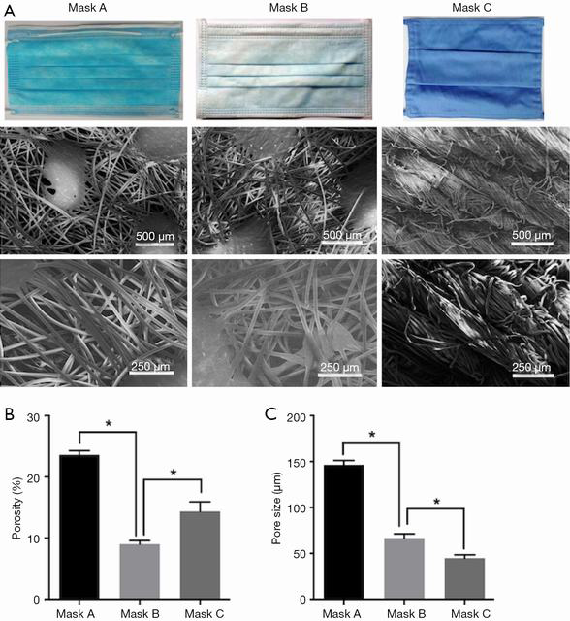
http://atm.amegroups.com/article/view/32465/html
http://cdn.amegroups.cn/journals/amepc/files/journals/16/articles/32465/public/32465-PB4-7346-R1.png

Cotton cloth photo at 40x magnification

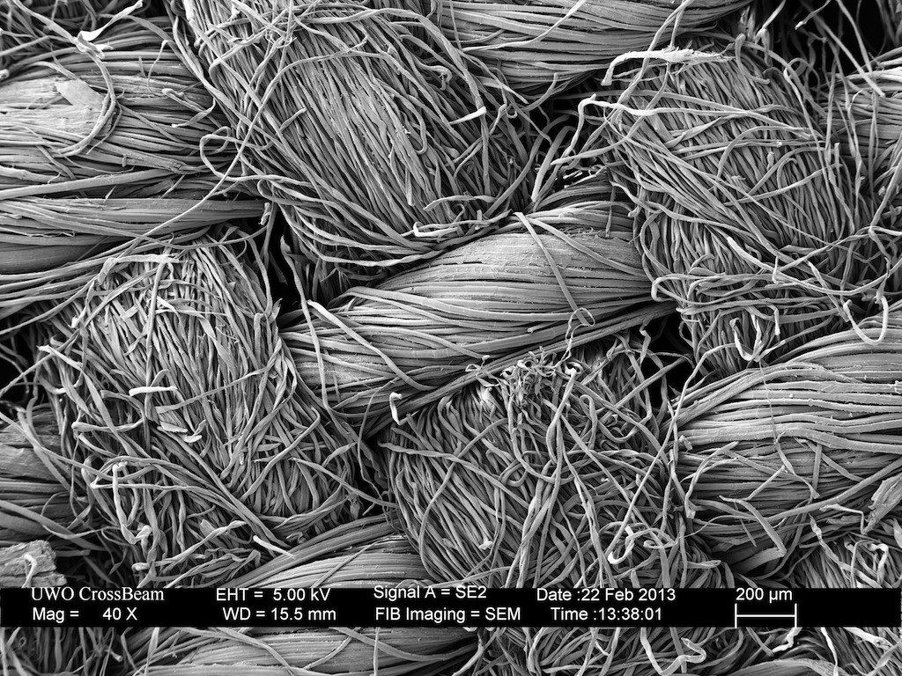
https://i.pinimg.com/originals/8e/cf/29/8ecf29ee6e2062ed0d92313042e58dd3.jpg

N-95 Respirator, at 20 micron resolution, scanning electron microscope

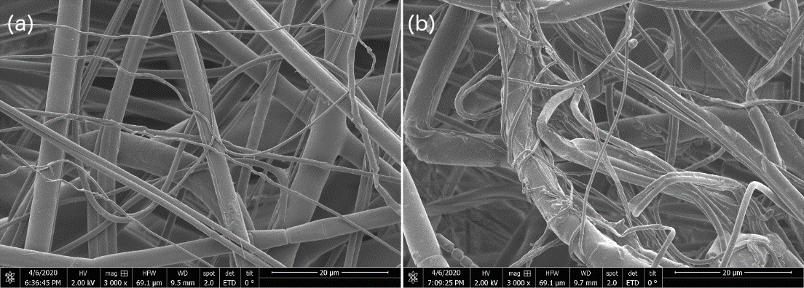
https://groups.oist.jp/sites/default/files/imce/u92/fmask/SEM200mu.png

C Huber. Masks are neither effective nor safe: A summary of the science. Jul 6 2020. Primary Doctor. https://www.primarydoctor.org/masks-not-effect
Occupational Safety and Health Administration (OSHA), US Department of Labor. Confined or enclosed spaces and other dangerous atmospheres. https://www.osha.gov/SLTC/etools/shipyard/shiprepair/confinedspace/oxygendeficient.html
S Sharma, B. Brown. Spirometry and respiratory muscle function during ascent to higher altitudes. Lung. Mar-Apr 2007. 185 (2): 113-21. doi: 10.1007/s00408-006-0108-y https://pubmed.ncbi.nlm.nih.gov/17393241/
S Malik, I Singh. Ventilatory capacity among highland Bods: a possible adaptive mechanism at high altitude. Ann Hum Biol. Sep-Oct 1979. 6 (5) 471-6. doi: 10.1080/03014467900003851 https://pubmed.ncbi.nlm.nih.gov/533244/
W Williams. Physiological response to alterations in [O2] and [CO2]: relevance to respiratory protective devices. J Int Soc Resp Protection. National Institute for Occupational Safety and Health (NIOSH). 27 (1): 27-51. 2010. https://www.isrp.com/the-isrp-journal/journal-public-abstracts/1154-vol-27-no-1-2010-pp-27-51-wiliams-open-access/file
I Holmer, K Kuklane et al. Minute volumes and inspiratory flow rates during exhaustive treadmill walking using respirators. Ann Occup Hygiene. 51 (3): 327-335. Apr 2007. https://doi.org/10.1093/annhyg/mem004 https://academic.oup.com/annweh/article/51/3/327/139423
H Kobayashi, S Kanoh, et al. Diffuse lung disease caused by cotton fibre inhalation but distinct from byssinosis. Thorax. Nov 2004. 59 (12). https://thorax.bmj.com/content/59/12/1095
P Lai, D Christiani. Long-term respiratory health effects in textile workers. Curr Opin Pulm Med. Mar 2013. 19 (2): 152-157. doi: 10.1097/MCP.0b013e32835cee9a https://www.ncbi.nlm.nih.gov/pmc/articles/PMC3725301/
O Fadare, E Okoffo. Covid-19 face masks: A potential source of microplastic fibers in the environment. Sci Total Environ. Oct 1 2020. 737:140279. doi: 10.1016/j.scitotenv.2020.140279 https://www.ncbi.nlm.nih.gov/pmc/articles/PMC7297173/
Ibid O Fadare, E Okoffo.
J Cortez Pimentel, R Avila et al. Respiratory disease caused by synthetic fibers: a new occupational disease. Thorax. 1975. 30 (204): 205-19. https://www.ncbi.nlm.nih.gov/pmc/articles/PMC470268/pdf/thorax00140-0084.pdf
Z Liu, D Yu, et al. Understanding the factors involved in determining the bioburdens of surgical masks. Ann Trans Med. Dec 2019. 7 (23). http://atm.amegroups.com/article/view/32465/html
W Wuyts, C Agostini, et al. The pathogenesis of pulmonary fibrosis: a moving target. Eur Rep J. 2013 (41): 1207-1218. DOI: 10.1183/09031936.00073012 https://erj.ersjournals.com/content/41/5/1207
G Oberdorster, E Oberdorster, et al. Nanotoxicology: An emerging discipline evolving from studies of ultrafine particles. Environ Health Perspect. Jul 2005. 113(7): 823-839. doi: 10.1289/ehp.7339 https://www.ncbi.nlm.nih.gov/pmc/articles/PMC1257642/
C Scotton, R Chambers. Molecular targets in pulmonary fibrosis: the myofibroblast in focus. Chest. Oct 2007. 132 (4) 1311-21. doi: 10.1378/chest.06-2568. https://pubmed.ncbi.nlm.nih.gov/17934117/
J Byrne, J Baugh. The significance of nanoparticles in particle-induced pulmonary fibrosis. McGill J Med. Jan 2008. 11 (1): 43-50. https://www.ncbi.nlm.nih.gov/pmc/articles/PMC2322933/
D Bodian, H Howe. Experimental studies on intraneural spread of poliomyelitis virus. Bull Johns Hopkins Hops. 1941a; 69:248-267. https://www.cabdirect.org/cabdirect/abstract/19422700792
International Commission on Radiological Protection. Human respiratory model for radiological protection. Ann ICRP. 1994. 24: 1-300. The original of this article does not seem to be available. It was updated at this link: https://www.researchgate.net/publication/5658235_Updating_the_ICRP_human_respiratory_tract_model

